Digital Chip Design Program
RTL Design
Alia Alsultan
Elaf Alkhalaf
Lana Aldhali
Manar Alnuqaydan

Task #14
1/08/2026

Controller & Datapath

Task #14

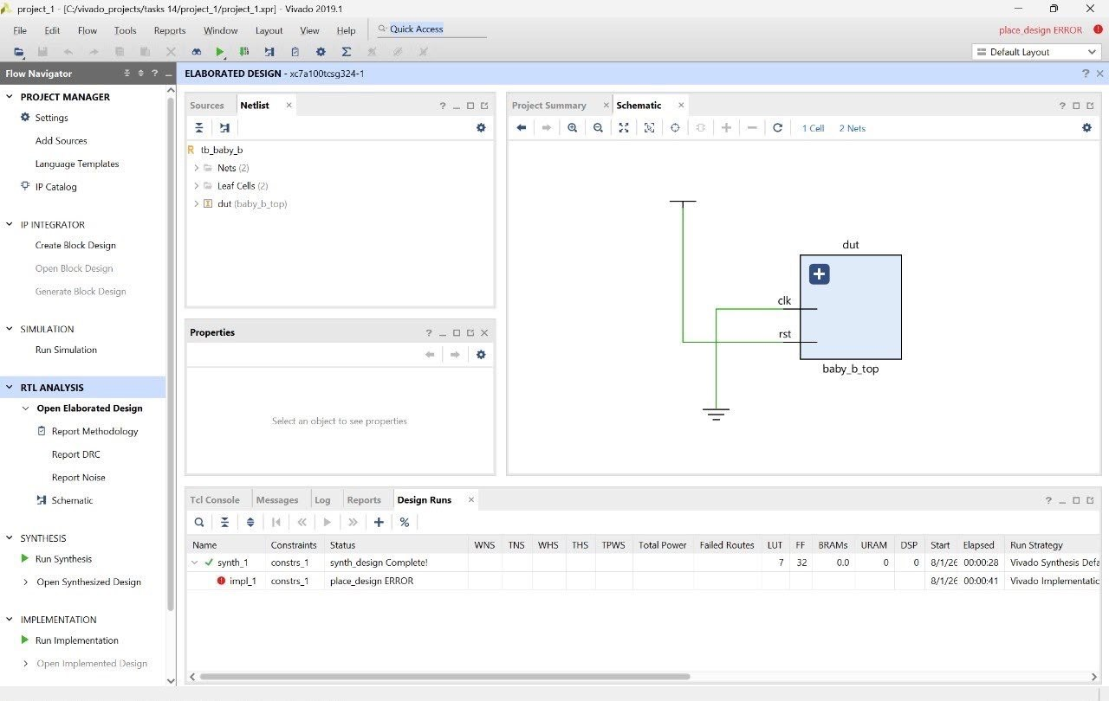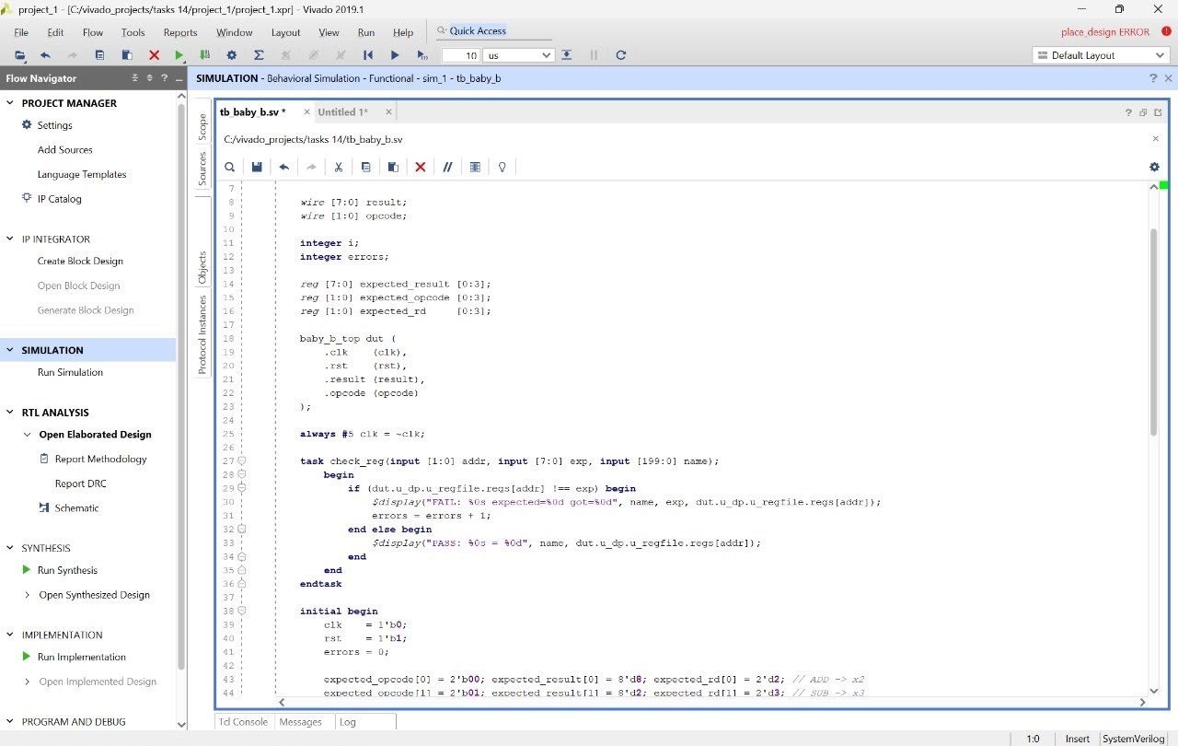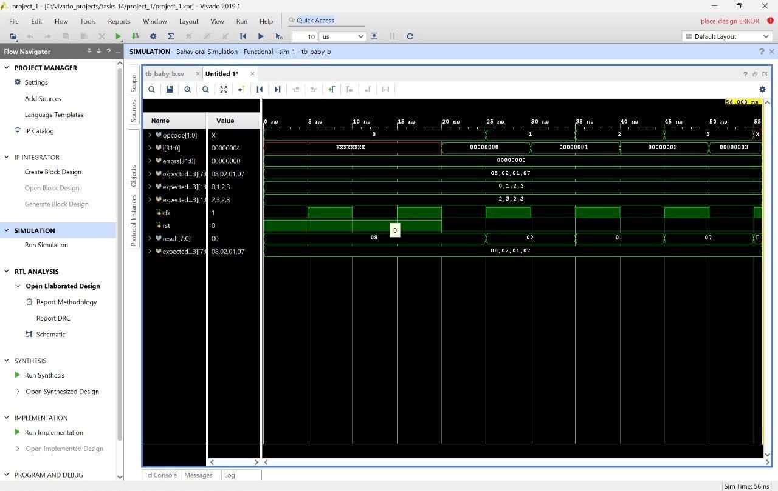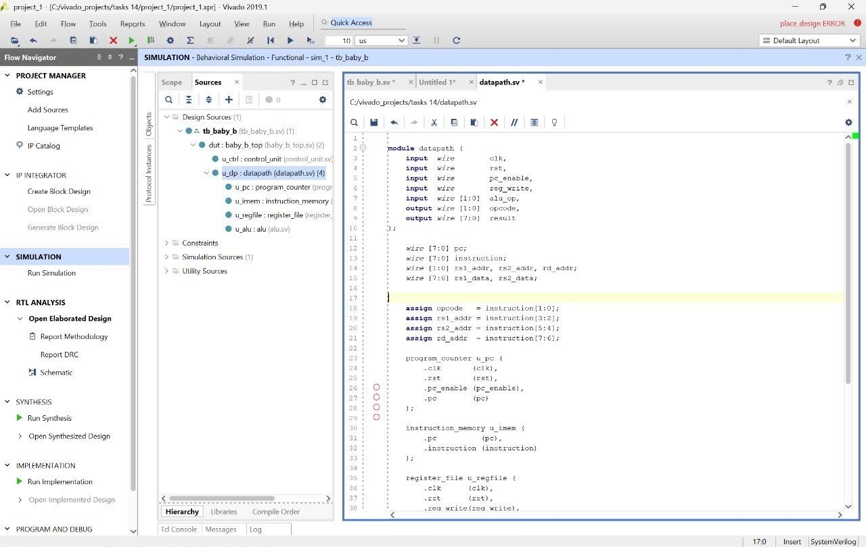

Work distribution

Section | Alia | Elaf | Lana | Manar
Report | ✔ | ✔ | ✔ | ✔
Task 14.1.1 | ✔ | ✔ | ✔ | ✔
Task 14.1.2 | ✔ | ✔ | ✔ | ✔
Task 14.1.3 | ✔ | ✔ | ✔ | ✔

